Journal:

Market Research

Based on the primary data and the secondary data we have defined a big problem in the sector that was conducted which is the use of plastic jars for supplements and this problem cause an increase the dioxins as well as CO2 emissions these both main problems would increase the heart diseases and air pollution.

Primary Data about cafeterias in the gym

After gathering the survey, we have found out that a great number of users faces a problem regarding the preparation in the supplement preparation as well as the main two problems faced are spelling supplements of the scoop and weighting the doses. In addition, we found out that multiple user’s intake must intake 3 supplements monthly but unfortunately the intake is one supplement due to affordability. Finally, the users are facing a problem in the flavor since all proteins contains artificial flavors buying large jars of supplements might cause a drawback in consistency because of its taste.

Primary Data about supplement users

* What is the amount of each supplement intake per month?
* Do you find it profitable?
* Do you have some left jars open due to the taste or other reasons?
* Weighing supplements in grams does it causes any losses?

Upon the interviews made with 4 different gyms we found out that multiple gyms faces losses while weighing in grams but they never measured this loss as well as they face problems in plastic jars that are opened for specific customer and then left open until expiry, they found this business very profitable and they would find it more profitable if they tackle these main problems since the usual intake per month is 60 jars from different supplements.

Secondary Data about supplements product

* Approximately 44% of gym users in Amman, Jordan, consume dietary supplements, according to a study.
* Among these users, protein supplements, including whey proteins and protein powder, are among the most consumed, with whey proteins at 48.6% and protein powder at 45.7%. This suggests a substantial portion of gym members in Amman incorporate protein supplements into their fitness routines.
* A study on dietary supplement prevalence among 397 participants found that 70.8% were consuming supplements, particularly proteins and vitamins.
* A study conducted in Jordan found that 60% of people who use dietary supplements include protein powder in their regimen.
* Another study mentioned that 80% of individuals in Jordan are familiar with dietary supplements, indicating a significant awareness of such products.

Secondary Data about plastic pollution

* Release of toxic chemicals: Burning Plastic emits harmful toxins such as dioxins in which 29% of world dioxins are caused of burning plastic, furans and polychlorinated biphenyls, which pose serious health risks including respiratory issues and cancer
* Impact on air quality: The process significantly destroys air quality, leading to potential health problems like heart disease and respiratory ailments.
* Healthcare costs: The health impacts from air pollution caused by burning plastics
* 70 million metric tons of plastic are burned worldwide each year

Studying the market:

1. Target Audience: In Jordan, the target audience for that goes to the gym are generally ages from 18-45 as well as cafeterias in gyms that focus on selling supplements in quantities.
2. Market Size: While Jordan's supplement market may be smaller compared to global markets, there is a growing interest in health and fitness among Jordanians, particularly in urban areas like Amman. The market size for protein supplements is on the rise as people become more aware of the importance of nutrition and exercise.

Challenge Statement

POV For Cafeterias:

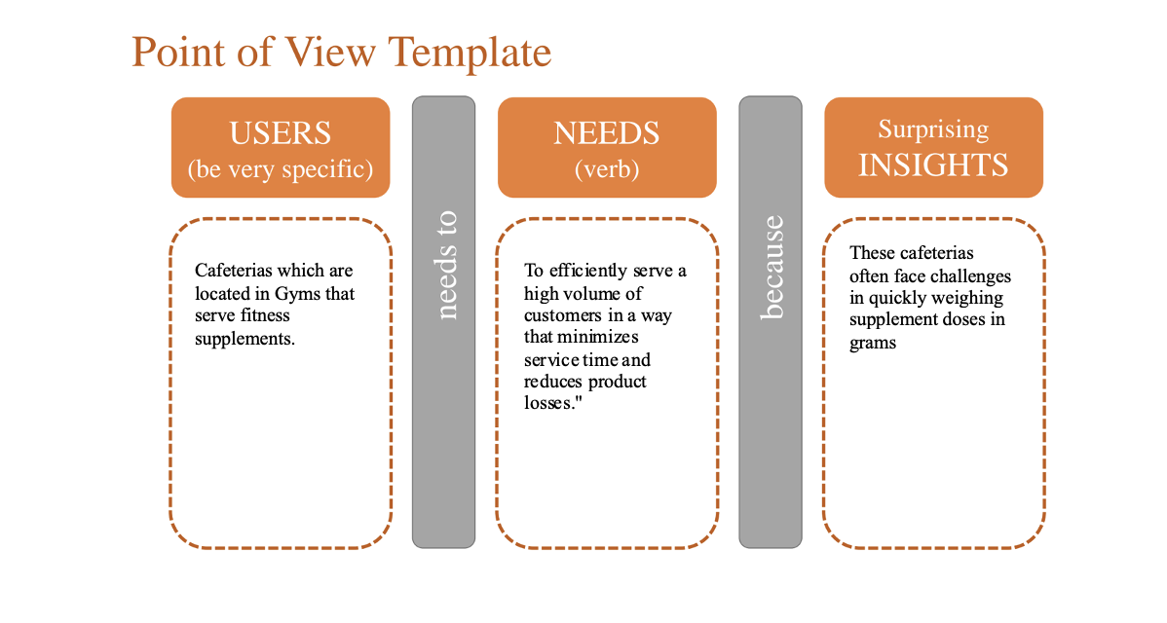

POV Statement:

Gym cafeteria managers need a more efficient method for weighing supplement doses toi redice wait times and product loss.

How might we achieve high accuracy in weighting supplement doses in a faster way than the traditinal way or how we can elimenate the weighting part?

POV for End Users:

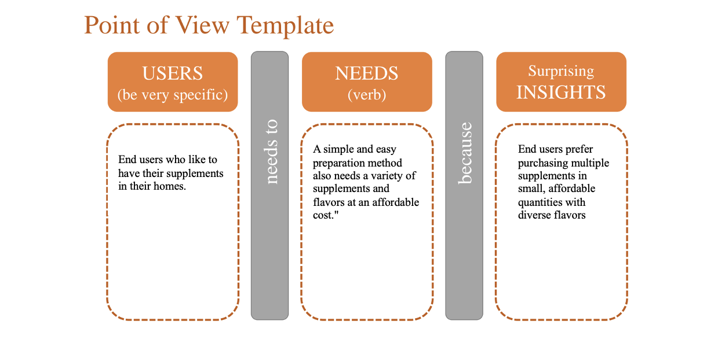

POV Statement:

End users need a way to afford a variety of supplements in smaller, more manageable quantities because they prefer to experiment with different flavors and supplement types without the need large-volume purchases.

HMW simplify the prosces of preparing any supplemts?

HMW offer supplements in smaller amounts that allows the user customize their supplemnts types and flavers?

FINAL POV Statement:

Both, personas are looking for more affordable and flexible supplement product

Business Idea:

Creatiforce aims to revolutionize the fitness nutrition industry by introducing a more efficient and user-friendly alternative to traditional protein jars: capsules. Our primary focus is to simplify supplement intake for athletes and fitness enthusiasts, providing them with a convenient solution for their nutritional needs.

Implementation Strategy:

1. Usability Enhancement: For athletes seeking to optimize their performance, Creatiforce offers a range of essential supplements including protein, creatine, and pre-workout formulas. By replacing bulky protein jars with easily consumable capsules, we streamline the supplement intake process, making it more manageable for users.
2. Eco-friendly Approach: In line with our commitment to sustainability, Creatiforce ensures that our capsule products are eco-friendly. We eliminate the need for plastic packaging commonly found in gym cafeterias by implementing refillable options displayed on wooden shelves. Moreover, our end-user packaging is crafted from sustainable materials, minimizing environmental impact.

Targeted Personas:

* Gym Cafeterias: Creatiforce caters to gym cafeterias by offering refillable capsule products, reducing plastic waste and promoting sustainability within their operations.
* End-users: Fitness enthusiasts benefit from our convenient and eco-friendly capsule solutions, making their supplement intake hassle-free while contributing to a greener planet.

Creatiforce's innovative approach not only simplifies the fitness nutrition process but also contributes to a more sustainable future for the industry.

Tools Used

1-Emphasizing: Gathering more information about our target audienceand their preferences, including the supplements they would like to take regularly and the appropriate doses.

2-  Brainstorming: After brainstorming various ideas to bring our concept to life, we initially came up with 3 to 4 ideas. However, as we discussed each idea as a team, we realized that we could come up with even better solutions. Our goal was clear: we wanted to reduce plastic waste in the cafiterias and to the gym members that would buy the prodcut and the suplements they think would suit them best.

3- Mind map are incredibly helpful for organizing ideas and visualizing connections in a project. They can clarify complex information, improve understanding, and stimulate creativity. Plus, they're a great tool for brainstorming and planning.

4- Inductive reasoning

The observation: we noticed that many gym cafeterias use a lot of plastic packaging for their supplements, and also the gym members that buy the protien, which contributes to environmental waste.

Generalization: from the observation we generalize that many gym cafetrias and gym members rely heavily on pastic packaging for their protein and suplements.

Theory: after this generalization we theorize that by replacing plastic packaging with eco-friendly alternatives, such as wooden shelves and sustainable materials, you can reduce plastic waste in gym cafeterias.

Inductive reasoning is a type of logical thinking that involves making generalizations based on specific observations or evidence. Instead of starting with a theory or hypothesis and testing it to see if it holds true, inductive reasoning works the other way around. It starts with specific observations and uses them to form a general conclusion. This method is used to develop theories and hypotheses in scientific research and is also commonly used in everyday reasoning to draw conclusions based on patterns or trends observed in specific cases.

Divergent thinking

It's a thought process or method used to generate creative ideas by exploring many possible solutions. This approach often involves thinking "outside the box," considering multiple perspectives, and generating a variety of ideas, even unconventional ones. Divergent thinking is about exploring possibilities and generating ideas without necessarily judging them for correctness or feasibility.

Evaluate the iterations:

Iterations #1 :

First iteration (Draw.io): we have met as a group to discuss the ideas that we came up with our discussion , we saw that the protein idea was one of the best ideas it offers athletes all their needs from supplements , we also thought how would we ease the intake process of supplements for these athletes . this is done by offering portable and user-friendly capsules, replacing cumbersome jars and containers. Athletes can select personalized nutrient combinations, enhancing usability and convenience.

* The draw.io sketch :

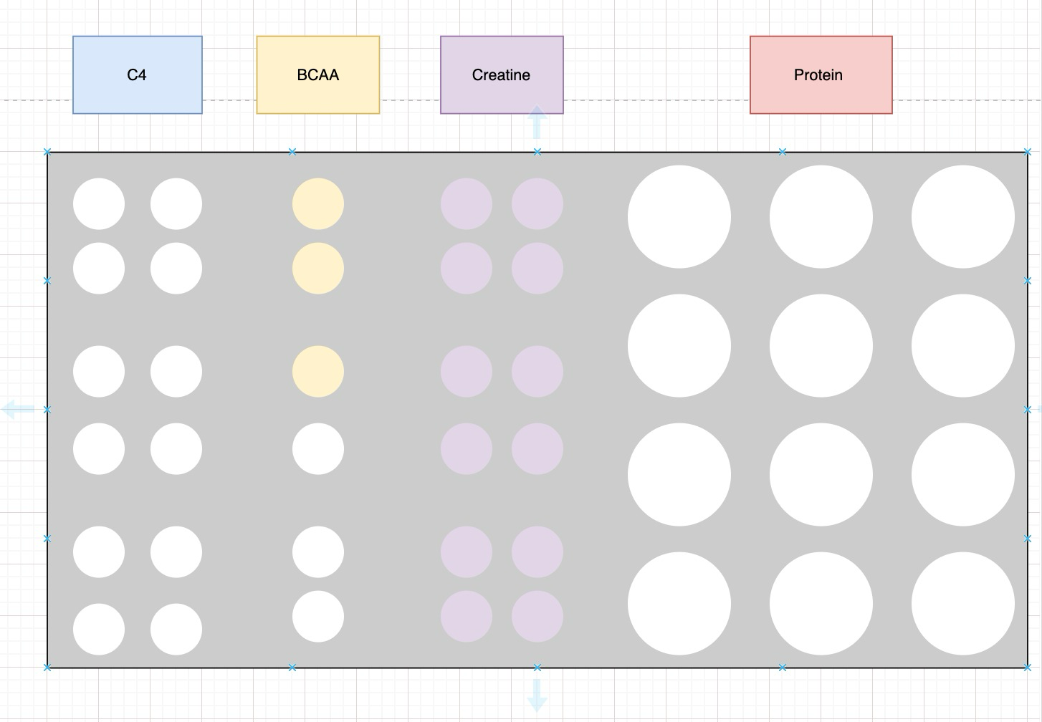

Iteration#2:

The second iteration was done according to the iteration above , we also gathered further details for drawing a sketch, after gathering enough feedback from different athletes we found that a great number are able to substitute their protein jars in an easy and more efficient protein capsules but they have mentioned they need more enthusiast packaging.

* The sketch :



Iteration #3:

As the ongoing research kept taking place, we needed a more detailed model for this packaging that was eco-friendly that has to be more enthusiast according to the iteration above, it was divided to three parts and included (protein, creatine, and pre workout). So, this is the initial prototype we are presenting now.

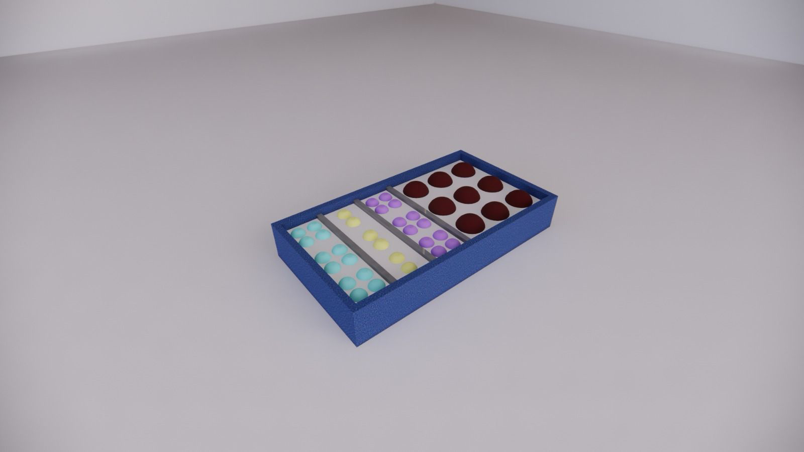



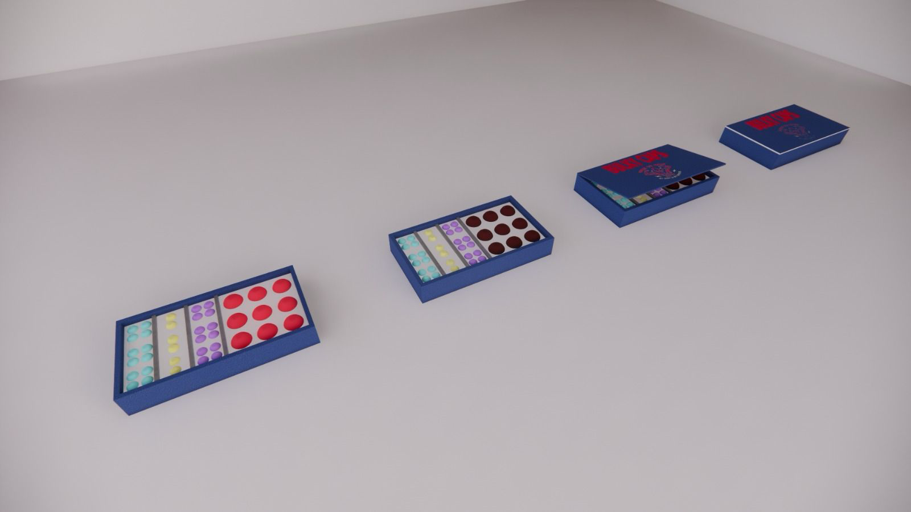



Validating the feedback

Gym Cafeterias questions about packaging:

* How do you find the package as branding?
* Will it cause any mess or make the cafeteria unclean?
* Would buy it for this price as a reusable one?
* Do you find separating each supplement in a package is good?

After asking 2 cafeterias for the packaging made, they had shown a very excitement regarding the package with no refusals for the initial design, but we must ask more cafeterias in gym to gather more data among this package. But both of them confirmed that this reusable package won’t lead to any mess and will keep the cafeteria clean.

End User questions about packaging?

* How do you find the branding?
* Do you like the separation of each supplement?
* Will it tackle your flavor problem?
* Is it affordable for your income?

As for the end users we iterated twice and ask people in the gym multiple questions as for the first and second iteration was through brainstorming but for the 3rd iteration it was taken into consideration from customer feedback as for the customers, they mentioned that the idea is great and it would solve multiple problems for them but they want a more attractive packaging so it would target their emotions.

Usability Scalability & Possibility

As to explain how our business idea can be implemented and brought to life is by using the mind map and tick every details for its possibility as we can make a capsule since they are already made for medicines, the only thing we need to make is to increase its water solubility so it can be shaken easily, also FDA approvals must be easy since the chemical component of the capsule is already in life and manufactures of supplements must be contacted to supply the raw materials.

Usability:

The product can enhance and bring the scale of supplements usability into another level by getting the capsule and shaking it with water without the need of measuring any tiny grams, this will also make the cafeteria selling power much higher.

Scalability:

As to think of scaling our company CreatiForce must think of introducing new ideas into this product, as for the initial ideas written, the capsule has certain flavors introduced by the supplements company, to think bigger we can make customized flavors that can be sell in higher price. Since, the product is easy to scale and has the functionality of being edited on we can sell it in pharmacies to be a prescription for people who lack certain types of proteins.